**Bootstrap list groups** are useful for displaying simple lists of elements, as well as complex ones with custom content.

**Basic list group :** To create a basic list group, create an unordered list. Use .list-group class on the <ul> element and list-group-item class on the <li> element.

<ul class="list-group">

    <li class="list-group-item">India</li>

    <li class="list-group-item">USA</li>

    <li class="list-group-item">UK</li>

</ul>

**Output :**   
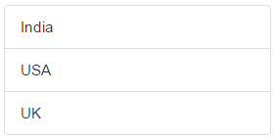  
  
**List group item with a badge :** To create a badge, include a <span> element with .badge class inside the <li> element.

<ul class="list-group">

    <li class="list-group-item">India</li>

    <li class="list-group-item">USA</li>

    <li class="list-group-item">UK</li>

    <li class="list-group-item">

        Australia

        <span class="badge">New</span>

    </li>

</ul>

**Output :** Notice the new country **"Australia"** is displayed with the badge **"New"**   
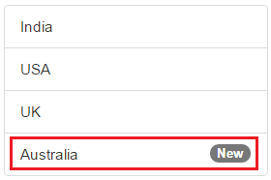  
  
**List group with hyperlinks :** To create list group with hyperlinks, use <div> instead of <ul> and <a> instead of <li>

<div class="list-group">

    <a href="http://dell.com" class="list-group-item">Dell</a>

    <a href="http://google.com" class="list-group-item">Google</a>

    <a href="http://microsoft.com" class="list-group-item">Microsoft</a>

</div>

**Output :** On hover the cursor changes to a hand symbol and the background colour changes to grey. When you click on an item, you will be redirected to the respective URL.   
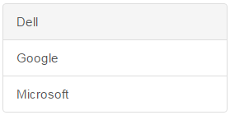  
  
**Styling list items :** Use contextual classes to style the list items. The following are the contextual classes   
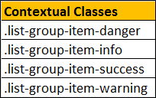

<ul class="list-group">

    <li class="list-group-item list-group-item-danger">India</li>

    <li class="list-group-item list-group-item-info">USA</li>

    <li class="list-group-item list-group-item-success">UK</li>

    <li class="list-group-item list-group-item-warning">Australia</li>

</ul>

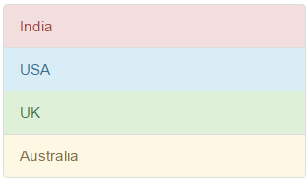  
  
**Highlight and disable list group items :** Use .active class to highlight a list-group-item and .disabled class to disable a list item.

<ul class="list-group">

    <li class="list-group-item disabled">Disabled Item</li>

    <li class="list-group-item active">Active Item</li>

    <li class="list-group-item">Other Item 1</li>

    <li class="list-group-item">Other Item 2</li>

</ul>

**Output :**   
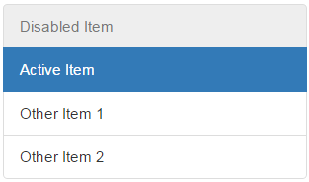  
  
**List group custom content :** List groups can contain your own custom content. Nearly any HTML can be used. We will use the following 3 classes to create list group with custom   
content.   
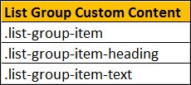

<div class="list-group">

    <a href="#" class="list-group-item">

        <h4 class="list-group-item-heading">List Group Item 1 Heading</h4>

        <p class="list-group-item-text">List Group Item 1 Text</p>

    </a>

    <a href="#" class="list-group-item">

        <h4 class="list-group-item-heading">List Group Item 2 Heading</h4>

        <p class="list-group-item-text">List Group Item 2 Text</p>

    </a>

    <a href="#" class="list-group-item">

        <h4 class="list-group-item-heading">List Group Item 3 Heading</h4>

        <p class="list-group-item-text">List Group Item 3 Text</p>

    </a>

</div>

